Click here, type the title of your paper, Capitalise first letter only (not all words)
First Author¹, Second Author^{2*} , Third Author³, Fourth Author^{4,5}
^{1,2,3,4}First affiliation, City and Country
⁵Second affiliation, City and Country

ARTICLE INFO |  | ABSTRACT
Article history:  Received XX Month 20XX  Revised XX Month 20XX  Accepted XX Month 20XX  Online first  Published XX Month 20XX |  | The abstract word count should not be more than 300 words. Please format your abstract using the ‘Abstract’ style in the style’s gallery.  The line numbers on the left allow easier referencing and communication between the author and reviewers during double-blind peer review. Please do not remove the line numbers.  Please do not edit or remove any texts or objects highlighted in red.  Please read the content of this guideline entirely. Failure to adhere to this guideline shall lead to manuscript rejection at the desk evaluation stage.
Keywords:
Keyword1
Keyword2
Keyword3
Keyword4
Keyword5
Keyword6
DOI:
10.24191/mjcet.vXiX.XXXXX
- Insert your heading here (do not copy paste)
The paragraphs continue from here and are only separated by headings, subheadings, images, and formulae. The section headings are arranged by numbers, bold and 10 pt. Here are further instructions for authors.
  - Structure of MS word formatting
Files should be in MS Word format only and should be formatted for direct printing. Figures and tables should be embedded and not supplied separately. Please make sure that you use as much as possible normal fonts in your documents. Special fonts, such as fonts used in the Far East (Japanese, Chinese, Korean, etc.) may cause problems during processing. To avoid unnecessary errors, you are strongly advised to use the ‘spellchecker’ function of MS Word. A UK English language is set as default for the
entire manuscript. Kindly ensure the manuscript is well written with minimum language errors. Any poorly written manuscript will not be accepted at the initial screening stage. Follow this order when typing manuscripts: Title, Authors, Affiliations, Abstract, Keywords, Main text (including figures and tables), Acknowledgements, References, Appendix. Collate acknowledgements in a separate section at the end of the article and do not include them on the title page, as a footnote to the title or otherwise.
Bulleted lists may be included and should look like this:
- First point
- Second point
- And so, on
Ensure that you return to the ‘Main Text’ style, the style that you will mainly be using for large blocks of text, when you have completed your bulleted list.
Please do not alter the formatting and style layouts which have been set up in this template document. As indicated in the template, papers should be prepared in single column format. Do not number pages on the front, as page numbers will be added separately for the preprints. Ensure, to leave a line clear between paragraphs by using the right styles (MAINTEXT). All the required style templates are provided in this document with the appropriate name supplied. Please refer to page 9 for complete guide on styles.
  - Tables
All tables should be numbered with Arabic numerals. Headings should be placed above tables, left justified, and bold. Leave one line space between the heading and the table, by choosing Table Caption in the Styles Gallery. Only horizontal lines should be used within a table, to distinguish the column headings from the body of the table, and immediately above and below the table. Tables must be embedded into the text and not supplied separately. The source of data must be provided i.e., literature (s) or author’s own data. Below is an example which authors may find useful.
Table 1. An example of a table (Font = 9; Click ‘Table Caption’ on the Styles Gallery; No period at end of caption)
An example of a column heading | Column A (t) | Column B (T)
And an entry | 1 | 2
And another entry | 3 | 4
And another entry | 5 | 6
Source: (Font = 9; Click ‘Normal, Source’ on the Styles Gallery)
  - Construction of references
References should be listed at the end of the paper, should be arranged first alphabetically and then further sorted chronologically if necessary. More than one reference from the same author(s) in the same year must be identified by the letters “a”, “b”, “c”, etc., placed after the year of publication.
Some examples of how your references should be listed are given at the end of this template in the ‘References’ section which will allow you to assemble your reference list according to the correct format and font size. Table 2 shows a guide on construction of different type of reference.
  - Section headings
Section headings (Level A) should be left justified, with all letters capitalised, bold, and numbered consecutively, starting with the INTRODUCTION. Sub-section headings should be in sentence case (Level B), bold, and numbered 1.1, 1.2, etc; and lower-case italic (Level C) letters; and left justified, with second and subsequent lines indented. You may need to insert a page break to keep a heading with its text.
  - General guidelines for the preparation of your text
Avoid hyphenation at the end of a line. Symbols denoting vectors and matrices should be indicated in bold type. Scalar variable names should normally be expressed using italics. Dimensions and units of measures should be expressed in SI units. Table 3 shows typical units of measure for this journal. Please title your files in this order firstauthorname.docx.
Table 3. Typical units of measure for MJCET
Item | Dimensions/Parameter | Units  Dos and don’ts | Remark
Units and symbols | Temperature | 30 °C not 30 ºC | Insert symbol degree sign instead of superscript ‘o’
Units and symbols |  | −30 °C not -30 °C | Insert symbol minus sign instead of hyphen
Units and symbols | Absorbance  FTIR length | 1398 cm⁻¹ not 1398 cm⁻¹ | Insert symbol minus sign instead of hyphen
Units and symbols | Volume | 15 L not 15 l | Use L instead of l
Units and symbols | Weight | 150 g not 150g | Always insert space after number for a unit of measure
Units and symbols | Scientific number | 1.3614 × 10⁻⁶ not 1.3614 x 10⁻⁶ | Insert multiplication symbol instead of using ‘x’
Units and symbols | Percentage | 34 wt% not 34 wt.% or 34wt.%  35% not 35 % | No period after abbreviation weight  No space before %
Units and symbols | Units and symbols | C–O–C or C–H; not C-O-C or C-H | Use en-dash instead of hyphen to present bonding

Source: ACS Style Guide (2017) (Font = 9; Click ‘Normal, Source’ on the Styles Gallery
Table 2. Citation style and reference format for different type of references
  - Footnotes
Footnotes should be avoided if possible. Necessary footnotes should be denoted in the text by consecutive superscript letters. The footnotes should be typed single spaced, and in smaller type size (8pt), at the foot of the page in which they are mentioned and separated from the main text by a short line extending at the foot of the column. The ‘footnote’ style is available in this template for the text of the footnote.
  - Referencing and citation style
The manuscript’s references and citations should be written using the APA 7th edition style. In terms of the in-text citation style, APA uses the author's last name and the year of publication, for example: (Field, 2005); (Field & Thomas; 2014). If there are three or more authors, cite only the surname of the first author followed by “et al.” and the year., for example: (Field et al., 2017). For direct quotations, include the page number as well, for example: (Field, 2005, p. 14). Citing same authors of the same year should be assigned by alphabet following the year of publication (e.g., Field et al., (2014a); Field et al., (2014b)).
Table 2 shows the details of referencing according to the APA 7th edition style. The sample references are available on page 4. Please refer to the following website for further details on APA 7th edition referencing style: https://libraryguides.vu.edu.au/apa-referencing
- Author artwork
All figures should be numbered with Arabic numerals (1,2,...n). All photographs, schemas, graphs and diagrams are to be referred to as figures. Line drawings should be good quality scans or true electronic output. Low-quality scans are not acceptable. Figures must be both embedded into the text and all images should met the minimum requirement of 500 × 500 pixels. Lettering and symbols should be clearly defined either in the caption or in a legend provided as part of the figure. Figures should be placed at the top or bottom of a page wherever possible, as close as possible to the first reference to them in the paper.
  - Diagrams
Diagrams can be in the form of framework, process flow, chart, or any visual aids that are meant to support the written text. Any diagrams built using Microsoft Word or Microsoft Power Point’s Smart Art Graphic Tool needs to be embedded as editable or vector-based objects (instead of image objects). Diagrams attached using bitmap-based images (jpeg., png., and other formats) need to be in high resolution (at least 300 pixels per inch).

Texts embedded in diagrams
The font used for labels or indicators inside the diagram needs to be formatted as Times New Roman with font size set at 9. It must not be bold, italicised, or underlined.
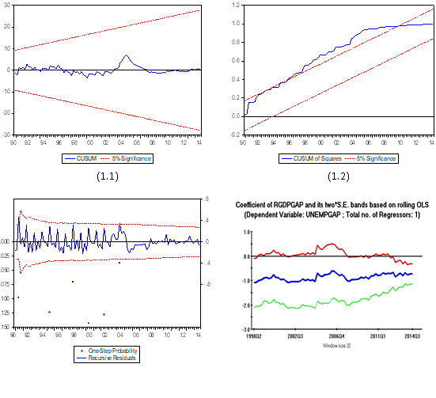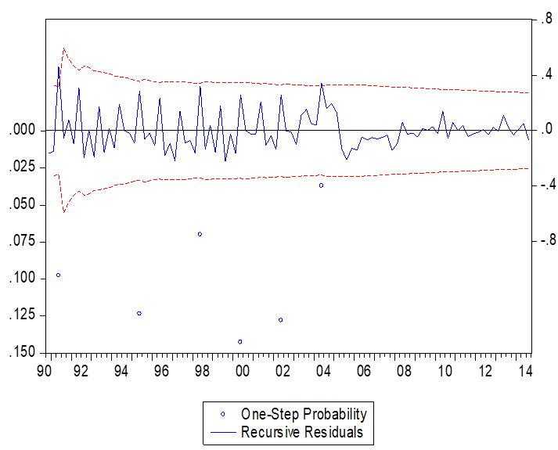
Fig. 1. (left) this figure is blurry, which is unacceptable; (right) this figure has a higher resolution. However, the labels are not formatted using Times New Roman font. (Font = 9; Click ‘Figure Caption’ on the Styles Gallery; No period at end of caption)
Source: Author X (20YY) (Font = 9; Click ‘Normal, Source’ on the Styles Gallery; No period at end source)
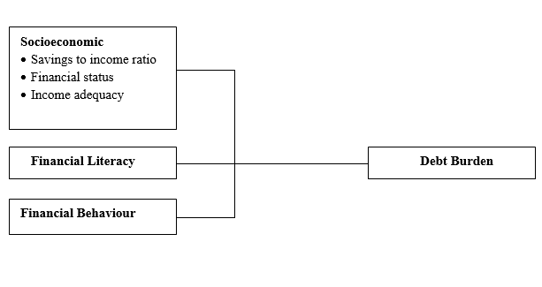
Socio-economic factors
Savings to income ratio
Financial status
Income adequacy
Financial literacy
Financial behaviour
Debt burden

Fig. 2. (left) this framework is a non-editable diagram, appears blurry and hence, is unacceptable;
(right) this framework is built using MS Word illustration tools, has higher resolution and is acceptable.
(Font = 9; Click ‘Figure Caption’ on the Styles Gallery; No period at end of caption)
Source: Author (Font = 9; Click ‘Normal, Source’ on the Styles Gallery; No period at end source)

Please use the ‘drawing canvas tool’ in MS Word before inserting any images or diagrams into the document. When constructing a conceptual/theoretical framework, please use editable or vector-based diagrams. Draw diagrams using MS Word’s Smart Art Graphic Tool (textboxes, labels, arrows, legends, etc.) rather than embedding non-editable image objects. Ensure that all the figures have a good resolution (minimum 300dpi) and are not fuzzy or blurry.
  - Captions
The figure number and caption should be typed below the illustration in 9pt and left justified. Artwork has no text along the side of it in the main body of the text. However, if two images fit next to each other, these may be placed next to each other to save space, see Fig. 1. They must be numbered consecutively, all figures, and all tables respectively.
- Equations and formulas
Equations and formulae should be typed and numbered consecutively with Arabic numerals in parentheses on the right-hand side of the page (if referred to explicitly in the text). They should also be separated from the surrounding text by one space. Eq. (1) shows the sample of equation position in a manuscript. If you chose to use the Equation Editor, please ensure that the manuscript is saved using .docx format
(rather than .doc), and Compatibility Mode is turned off.
 | Rt = K EP = 93.02 (± 9.62) – 13.45 | (1)
- ACknowledgements/Funding
This section is compulsory. The following is an example of an acknowledgement statement:
The authors would like to acknowledge the support of Universiti Teknologi MARA (UiTM), Cawangan Negeri Sembilan, Kampus Kuala Pilah and Faculty of Applied Sciences, Universiti Teknologi MARA, Shah Alam, Selangor, Malaysia for providing the facilities and financial support on this research.
- Conflict of interest statement

This section is compulsory. The following is an example of a conflict-of-interest statement:
The authors agree that this research was conducted in the absence of any self-benefits, commercial or financial conflicts and declare the absence of conflicting interests with the funders.
- Authors’ contributions
Each author contribution must be stated clearly reflecting each contribution to the body of the work and manuscript. Authors can refer to CRediT (Contribution Roles Taxonomy) for the detailed information about individual contributions to the work. For example:
Anis Muneerah Shaiful Bahari: Conceptualisation, methodology, formal analysis, investigation and writing-original draft; Nurhaswani Alias: Conceptualisation, methodology, and formal analysis; Zainovia Lockman: Conceptualisation, formal analysis, and validation; Haslina Misran: Conceptualisation, supervision, writing- review and editing, and validation.
- Declaration of generative ai in the writing process
This section is required if AI was used in the writing process. Authors must disclose the use of generative AI and AI-assisted technologies in the writing process by including a formal statement within their manuscript. In accordance with academic integrity standards, AI and AI-assisted technologies should not be listed as an author or co-author, nor should they be cited as an author, as authorship implies legal and ethical accountability that these tools cannot fulfil. The application of these technologies is strictly restricted to improving the readability and language quality of the work. Authors remain ultimately responsible and accountable for the original content, accuracy, and integrity of the entire manuscript. The declaration shall be written as follows:
During the preparation of this work, the author(s) used [NAME TOOL / SERVICE] in order to [REASON]. After using this tool/service, the author(s) reviewed and edited the content as needed and take(s) full responsibility for the content of the publication.
Note: If no AI assistance was used, this section is not required.

- data availability/supplementary materials
To foster research transparency and ensure the reproducibility of findings, authors are encouraged to provide all supplementary materials that support the primary research. This includes, but is not limited to, extensive datasets, original source code, high-resolution multimedia, or detailed experimental protocols. These materials should be hosted on reputable, permanent repositories and must be cited accordingly within the main text. It is the authors' responsibility to ensure that all supplementary files are accessible and provided in formats that facilitate ease of use for the scientific community. Furthermore, authors must include a dedicated "Supplementary Materials" section at the end of the manuscript containing a persistent link—ideally a Digital Object Identifier (DOI) or a stable URL—to ensure direct and permanent access to the hosted resources. Example of statement shall be as follows:
- Available upon request:
The datasets used and/or analysed during the current study are available from the corresponding author on reasonable request.
- Public Repository:
The datasets generated during the current study are available in the [Name of Repository] repository, [Web Link/DOI] etc.
- Data included in the article:
All data generated or analysed during this study are included in this published article [and its supplementary information files].
- No data/Theory-based:
Data sharing is not applicable to this article as no new datasets were generated or analysed during the current study.

- ETHics statement
The Ethics Statement is a mandatory section for all manuscripts submitted to MJCET. It must be placed after the Conclusion and before the References. Authors must declare their adherence to ethical standards by selecting and adapting the most relevant statement(s) below:
Universal statement if the study does not involve living subjects:
The authors declare that this research did not involve human or animal subjects. All experimental procedures were performed following the institutional Safety, Health, and Environmental (HSE) protocols of [Insert Institution Name].
For research requiring ethics committee approval, particularly involving bio-engineering, toxicity studies or social surveys where human or animal subjects were involved, may use this statement:
This study was reviewed and approved by the Institutional Ethics Committee of [Insert Institution Name] (Approval No: XXXX/202X). All procedures involving human participants/animal subjects were in fulfilment of the ethical standards of the 1964 Helsinki Declaration. Informed consent was obtained from all participants, and data anonymity was strictly maintained throughout the study.

- References
Ahmed, I. I., & Gupta, A. K. (2010). Pyrolysis and gasification of food waste: Syngas characteristics and char gasification kinetics. Applied Energy, 87(1), 101–108. https://doi.org/10.1016/j.apenergy.2009.08.032
American Society for Testing and Materials (2015) standard test methods for proximate analysis of coal and coke by macro thermogravimetric analysis (ASTM D7582-15) West Conshohocken, PA. https://www.astm.org
Bavani, M. (2021, April 15). Putting an end to food waste. The Star. https://www.thestar.com.my/metro/metro-news/2021/04/15/putting-an-end-to-food-waste
Energy Commission. (2019). Malaysia Energy Statistics Handbook 2019. https://meih.st.gov.my/documents/10620/bcce78a2-5d54-49ae-b0dc-549dcacf93ae
Ian C. Kemp. (2007). Pinch analysis and process integration a user guide on process integration for the efficient use of energy (Second Edition). Butterworth-Heinemann, Elsevier.
Matali, S. (2019). Production and kinetic study of torrefied oil palm frond and leucaena leucocephala pellets for co-combustion with Silantek coal (Issue 28308) [Doctoral Thesis, Universiti Teknologi MARA]. UiTM Institutional Repository. https://ir.uitm.edu.my/id/eprint/28308
Thompson, C. (2012). How can we develop an evidence-based culture?. In J. V. Craig & R. L. Smith (Eds.), The evidence-based practice manual for nurses (3rd ed., pp. 323–357). Churchill Livingstone Elsevier. https://www.elsevier.com/books/the-evidence-based-practice-manual-for-nurses/craig/978-0-7020-4193-8
Vuthaluru, H. B. (2004). Thermal behaviour of coal/biomass blends during co-pyrolysis. Fuel Processing Technology, 85(2–3), 141–155. https://doi.org/10.1016/S0378-3820(03)00112-7
Yang, H., Li, J., Jiang, H., Hu, J., Zeng, J., & Nie, C. (2018, March 26–28). Alkaline-surfactant-polymer flooding: Where is the enhanced oil exactly? [Paper presentation]. Society of Petroleum Engineers (SPE) 2018 EOR Conference at Oil and Gas West Asia, Muscat, Oman. https://doi.org/10.2118/190340-MS
Yang, Y., Wang, G., Peng, C., Deng, Q., Yu, Y., He, X., Hu, T., Jiang, L., Shan, S., Zheng, Y., Zhi, Y., & Su, H. (2023). Microwave-assisted synthesis of l-aspartic acid-based metal organic aerogel (MOA) for efficient removal of oxytetracycline from aqueous solution. Applied Surface Science, 610, Article 155608. https://doi.org/10.1016/j.apsusc.2022.155608

© 2026 by the authors. Submitted for possible open access publication under the terms and conditions of the Creative Commons Attribution (CC BY-NC-ND) license (http://creativecommons.org/licenses/by/4.0/).

- An example appendix
Authors including an appendix section should do so after References section. Multiple appendices should all have headings in the style used above. They will automatically be ordered A, B, C etc.

- Example of a heading within an appendix
  - Example of a sub-heading within an appendix
There is also the option to include a subheading within the Appendix if you wish.

About the Authors
Please submit another separate file by naming it as “Author Information”. Avoid revealing the identity and information of the authors in the manuscript (that should be anonymous). Provide the following information in the separated file.
Author 1 (Full Name, without Titles/Designation), Please summarise the academic background and details of the author, and contact information (an e-mail address is compulsory). The authors’ biographical information will be displayed after the Reference List. Maximum number of words is 100.
Author Full Name 2 (Full Name, without Titles/Designation), Please summarise the academic background and details of the author, and contact information (an e-mail address is compulsory). The authors’ biographical information will be displayed after the Reference List. Maximum number of words is 100.
EXAMPLE:
Danial Rashid, PhD is Associate Professor in the Department of Management and Finance at the University of Nusantara. His main research activity is in the area of organizational innovation and organizational learning. He has published widely on these subjects in publications such as the International Journal of HRM, Industrial Marketing Management, Journal of Business Research, International Journal of Information Management and Management Decision. His can be reached through his email at danialrashid@nusantarauni.edu.my

Style Formatting: Special Instruction to Authors (Please read this)
- Authors are required to edit the template using Microsoft Word 2010 onwards.
- Authors must use the ‘Styles Gallery’ to format the written contents of the article.
- The Styles Gallery is located within the Home Ribbon, in the Styles Pane.
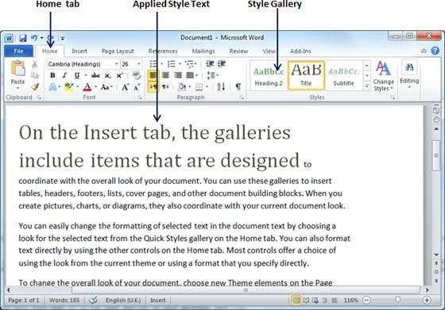

- The ‘Styles Gallery’ appears as follows:
- Please utilise the Styles Gallery when formatting your article.
- Please avoid doing the following:
  - adjust the paragraph parameters
  - add numbering to headings
  - increase or decrease indentation
  - create new headings
- If the formatting appears to stray away from the requirements, select the affected paragraphs/headings, and click the “Clear Formatting” icon at the ‘Font’ section of the ‘Home’
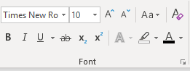

The formatting will be reset. Again, apply the intended formatting by clicking the specific style using the Styles Gallery.

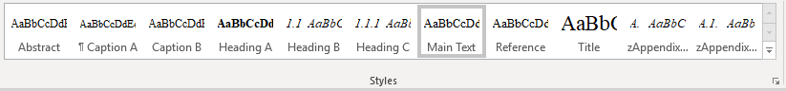
Please refer to the table below to understand the target use of each of the specific style.
Style Name | Targeted Use
Title | Main title
Author | Authors’ names  *corresponding author’s details are located at the footnote section of the first page
Affiliation | Author’s institutional affiliation
Footnote | Corresponding author’s e-mail address (use institutional e-mail address instead of free e-mail such as Gmail, Yahoo etc.)
Heading A | Main header with numbering (1,2,3…)
Heading B | Second level header (e.g. 1.1, 1.2, …)
Heading C | Third level header (e.g. 2.2.1, 2.2.2, …)
Main Text | The write-up of the article
- Main Text Heading A | The write-up right after Heading A
- Main Text Heading B | The write-up right after Heading B
- Main Text Heading C | The write-up right after Heading C
Normal, Source | For source reference.
Equation | For equation
Table Caption | Caption for Table
Figure Caption | Caption for Figure
Reference | Bibliographic reference with indentation
Appendix Heading 1 | Appendix header with lettering (A. B, C …)
Appendix Heading 2 | Appendix second-level header with alphanumeric coding (e.g. B1. B2, B3 …)

If you successfully adhere to this instruction, your article will be generated into a bookmarked PDF that is easy to be navigated by readers.

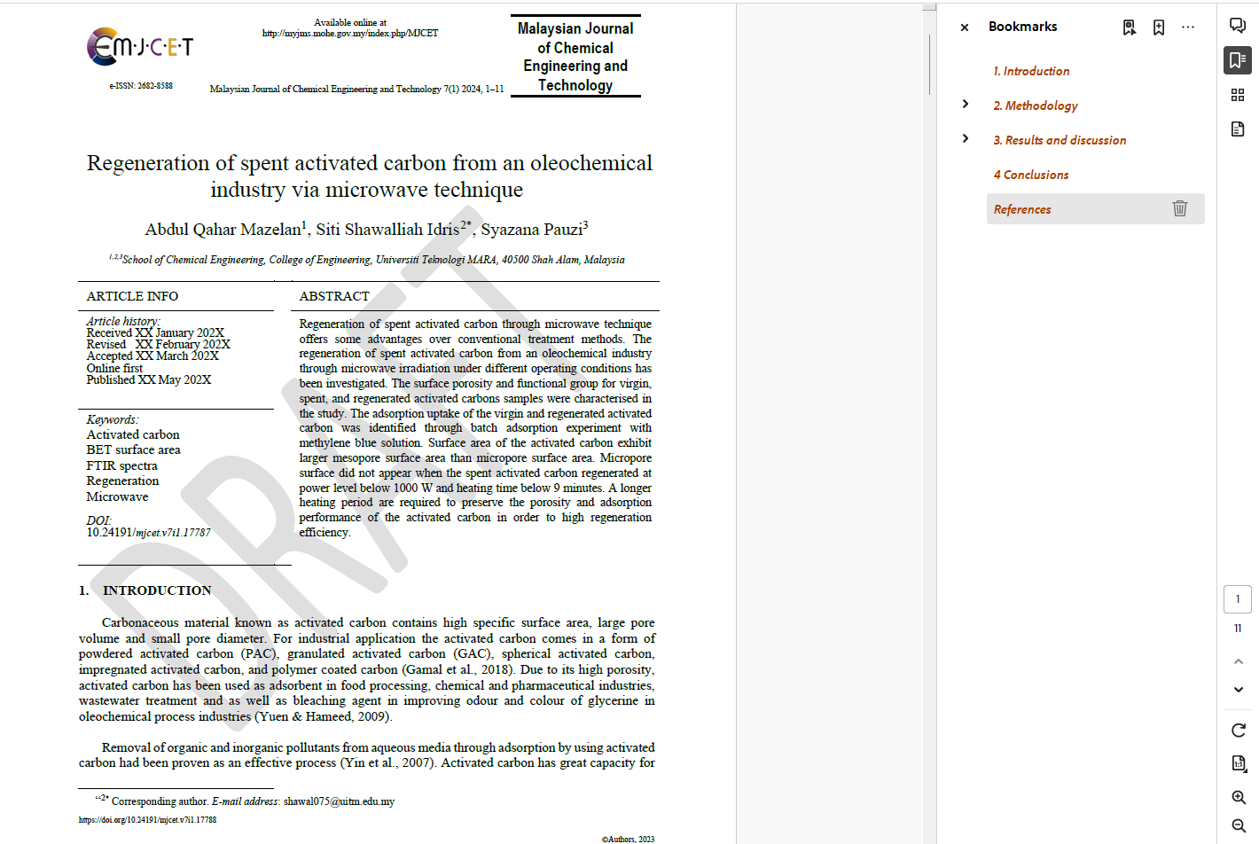

- This journal is a double-blind peer-reviewed open access journal that does not charge any publication fees. The journal is managed by volunteering academics of UiTM whose responsibilities include teaching, research, supervision, administration, and other academic obligations. Hence, your adherence to this guideline when submitting your manuscript is highly appreciated.

